HHFH Welcomes East Coast Spokesperson Daoud Torain ‘AKA’ SupaNova Slom.

HHFH, A SIGNATORY OF THE UN GLOBAL COMPACT, IS PLEASED TO WELCOME MR. DAOUD TORAIN, AKA SupaNova Slom AS EAST COAST SPOKESPERSON.

[] September 5^{th,} 2017: New York.
Hip Hop For Humanity [HHFH] [hhfhglobal.org] is pleased to report that Mr. Daoud Torain, AKA Supa Nova Slom, has been chosen and welcomed in the position of new East Coast spokesperson for hhfhglobal.org. This appointment continues a long relationship between Mr. Torain and HHFH Founder TaharQa Aleem.

The son of world-renowned healer Queen Afua, a by-product of the hip-hop renaissance and a survivor of the streets; SupaNova is a dynamic hip-hop recording artist, author, vegan body builder, wellness and community advocate. With a name that translates as ‘Shining with the brilliance of one hundred million stars’, SupaNova’s dedication to the well-being of young people is galvanizing a new possibility for the “now” generation.

SupaNova Slom’s multifaceted work includes his recently released best-selling book The Remedy: The Five-Week Power Plan to Detox the Body, Combat Fat, Rebuild Your Mind and Body, his supplement line Supa Mega Greens, his films: The Remedy, Wholistic Wellness for the Hip Hop Generation, and a number of critically acclaimed albums. He is the pioneer of the ‘Chlorophyllion’ green lifestyle and creator of the Hip Hop Meditation Ciphers.

Supa Nova Slom is a military combat veteran who has spoken internationally. He has appeared on Jay Leno, The Today Show (NBC) as well as BET and CBS.

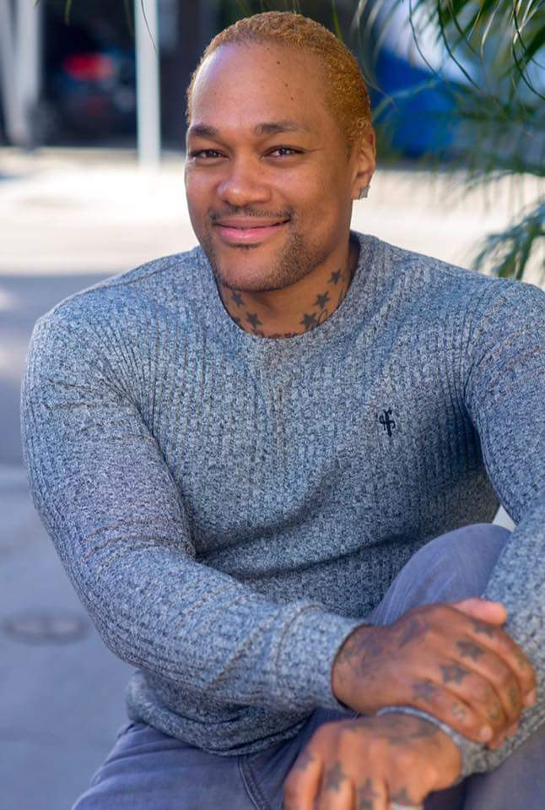

TaharQa Aleem, co-founder of HHFH, noted, “ Supa Nova and our families go back many years. We also worked together in the music industry. With Daouod’s community outreach programs that he currently is committed to, we mutually believe we bring best qualities to the relationship”.

HHFH is a recognized signatory to the United Nations Global Compact.

Our objectives and commitment at HHFH, among many, is to demonstrate responsible and sustainable development with a long term horizon for our various projects, with goods and benefits that flow into local communities, working with our local partners and collaborations to instill strength in the economy and the country.

HHFH believes it has a long-standing comprehensive approach to sustainability. HHFH is continually looking at and using essential elements of corporate sustainability. We are striving to: (1) operate responsibly in alignment with universal principles and (2) take strategic actions that support the society around us. Then, we continually look to push sustainability into our corporate identity, and (3) commit at the highest level, (4) evaluate and report annually on our efforts, and (5) engage locally where we have a presence, or, hope and plan to have a presence.

For more information, please visit us at: hhfhglobal.org

